Nº 1
Group:
 | Name |  | Nº
 | Name |  | Nº
 | Name |  | Nº

Fill in the header record with the name and number of the group members present in class. After finishing the exercises, add the doc to your group files section.
- Complete the following table by inspecting your robot and filling in the missing information. Signal the location of each port type by positioning the correspondent letter on top of the image.
Type of Port |  | Labels | Quantity | Location
A | Servomotors |  |  | 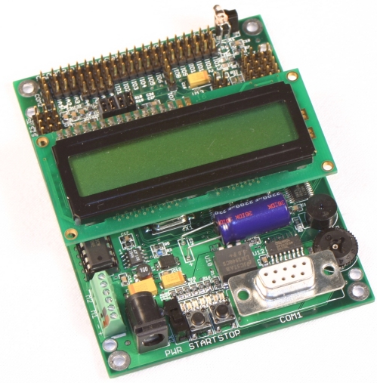  A  B
B | Analogical
C | Digital
D | I2C
E | Motor CC
F | RS-232

- How many devices with I2C interface can be connected to the corresponding port of the I2C IntelliBrain controller? (Tip: find out how many bits are used to address the devices).
R:

- What is the maximum current and maximum voltage supported by the DC motor ports of IntelliBrain controller?
R:

- Complete the following paragraph about the analog ports of the IntelliBrain controller.
The IntelliBrian 2 has ??? analog ports that can also be configured as ???. When reading the value of an analog port we obtains a value between ??? and ??? which is proportional to the voltage between ??? and ??? applied to the port signal pin. There is also a set of special analog ports prepared to connect ??? , and are identified with the labels ???.

- Complete the following paragraph about the digital ports of the IntelliBrain controller.
The IntelliBrian 2 has ????? digital ports that can be configured as ????? or ?????. When reading the value of a digital port we obtains a value of ??? or ??? which are respectively proportional to the voltage of??? and ??? applied to the port signal pin.

- Complete the following paragraph about the ports and pin arrangement.
The ground pin for each port is always the pin ???. The power pin is always the ???. The power pin is ??? for all ports except the ??? ports and the ??? port. The next pin third from the board edge is always ???. On four-pin ports, the fourth pin is ???.

- Complete the following table by inspecting your robot and filling in the missing information. Signal the location of each port type by positioning the correspondent letter on top of the image.

Type |  | Label | Quantity | Location
A | LCD | NA |  | A  B
B | Start and Stop Buttons
C | LEDs
D | Buzzer
E | Thumbwhell
F | IR Receiver | NA

- Describe possible applications for the following elements of the interface:
Thambwhell:
Buzzer:
LEDS:

